

**Farmers Market Analysis Project Report**

Computation and Visualization

IE6600-SEC 02

Name: Shashikanth Dhanekula

**Introduction:** To distribute agricultural products and to increase the revenue USA government has started a new strategy called as farmers market. In this report we analyze the data set provided by the USDA’s National Farmers Market Directory and we created some insights which provides a better understanding of the farmer’s market strategies.

Farmers market connects consumers with where and how their food is grown. It creates a new economic opportunity for producers and draws young people back to rural communities. It fosters appreciation for America’s farms and ranches and marketing opportunities for farmers, ranchers, chefs, and local food businesses. It connects schools and our Nation’s children with fresh, healthy food. And it helps increase healthy food access in rural and urban communities across the country.

**Data Exploration:**

**Dataset:** Data set is provided by USDA’s National Farmers Market Directory. Data set contains 59 columns. They are as follows:

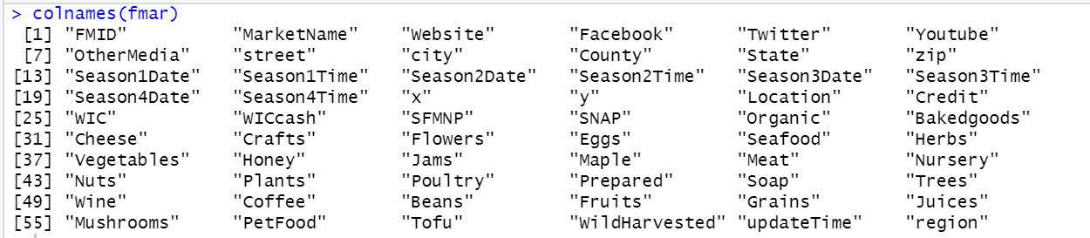

This data set has farmers market names, ID’s payment methods, location factors, type of products available in market and season related information. Dataset requires a fair amount of cleaning effort before starting analysis.

I have created multiple columns to segregate **states** as **different** **regions** and **goods** as **different products**.

**Columns:**

* FMID: This is a unique id for every dealer or seller in farmers market.
* Market Name: Name of the marketplace.
* Online Marketing platforms: Website, Facebook, Twitter, YouTube, Other media.
* Address: These are address related fields.
* Seasons: These columns are related to seasons in which markets are active in the region.
* Payment Methods: These are type of payment methods accepted in farmers market. They are Credit, WIC, WICCash, SNAP, SFMNP.
* Government related assistance programs: These are some of the assistance programs government has launched to boost the farmers market. They are SFMNP, SNAP
* Goods: These columns have the data of products available at farmers market.
* UpdateTime: The date and time at which a farmer or dealer registered in market.

**Analysis:** These are some of the analysis related to farmers market.

1. Government have funded almost 33% of total applications for farmers market. In 2008 it released $58 Million in the form of 879 grants.

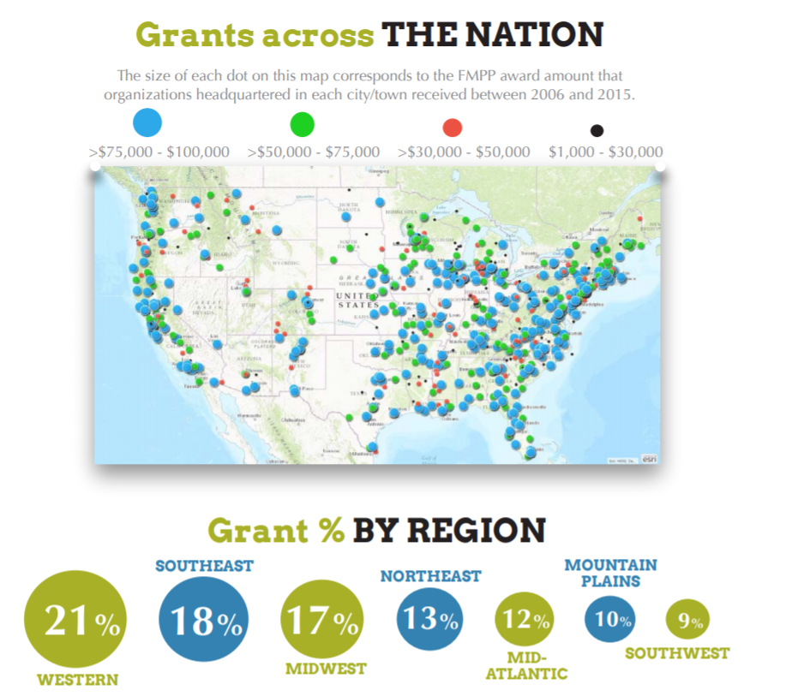

**Insights about Goods:**

Goods are the products which are sold in farmers market. I have divided these products into four different categories. They are as follows:

**Condiments:** Cheese, Crafts, Honey, Pet Food, Jams, Soap, Baked goods, Coffee.

**Meat Products:** Eggs, Seafood, Meat, Poultry, Prepared.

**Plant based food:** Organic, Vegetables, Nuts, Beans, Fruits, Grains, Juices, Mushrooms, Tofu.

**Other:** Plants, Trees, Flowers, Nursery, Wild Harvested, Herbs, Wine, Maple

* These are the Top 10 products which are sold across the farmers market. [1]From the bar graph we can observe that Vegetables and Baked goods are almost sold across ~70% in farmers market. And most of the plant-based products are sold across all regions.

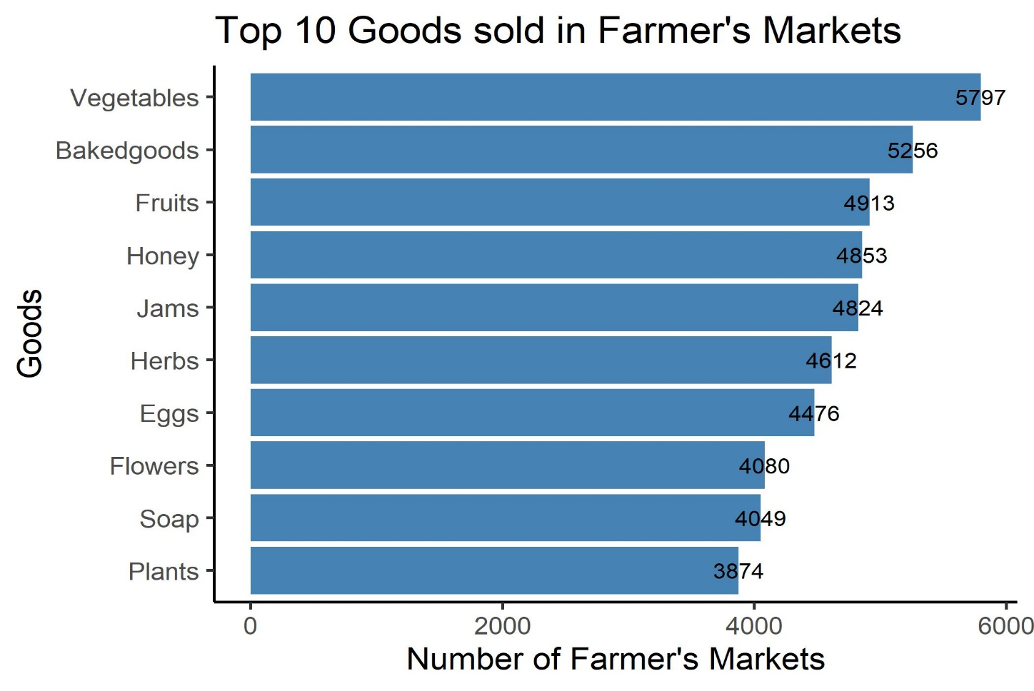

**Insights about Payment Types:**

* Around ~35% of sellers in farmers market accept credit as a primary method of payment.

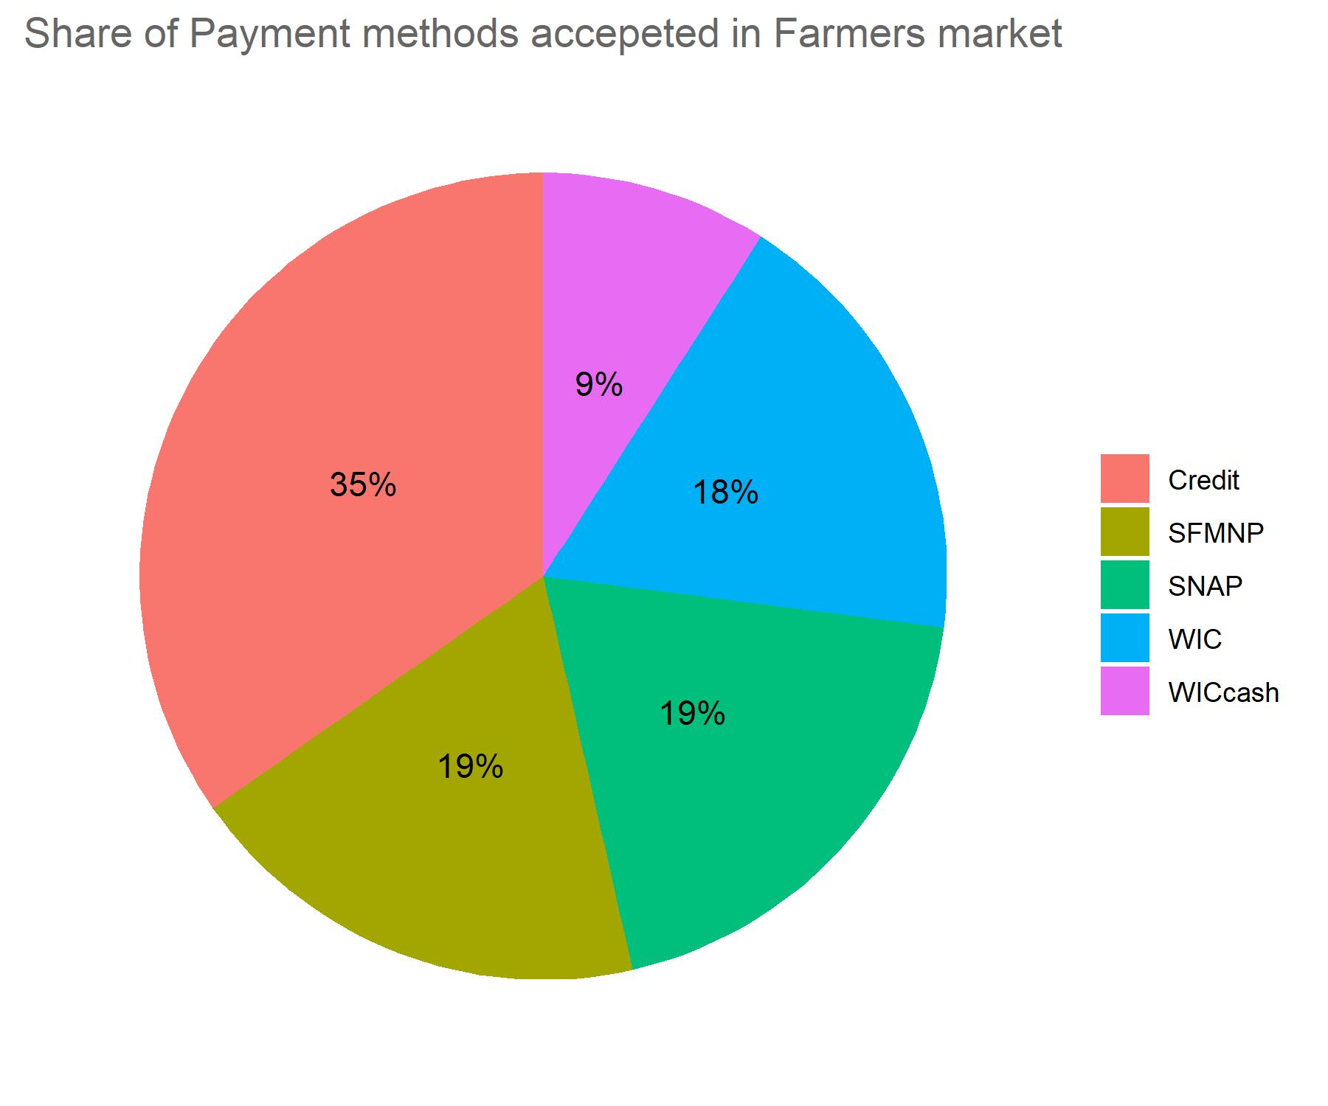

* Credit is the most popular type of payment method across all the regions. Farmer’s market in Northeast has a highest multi-payment acceptance rate.

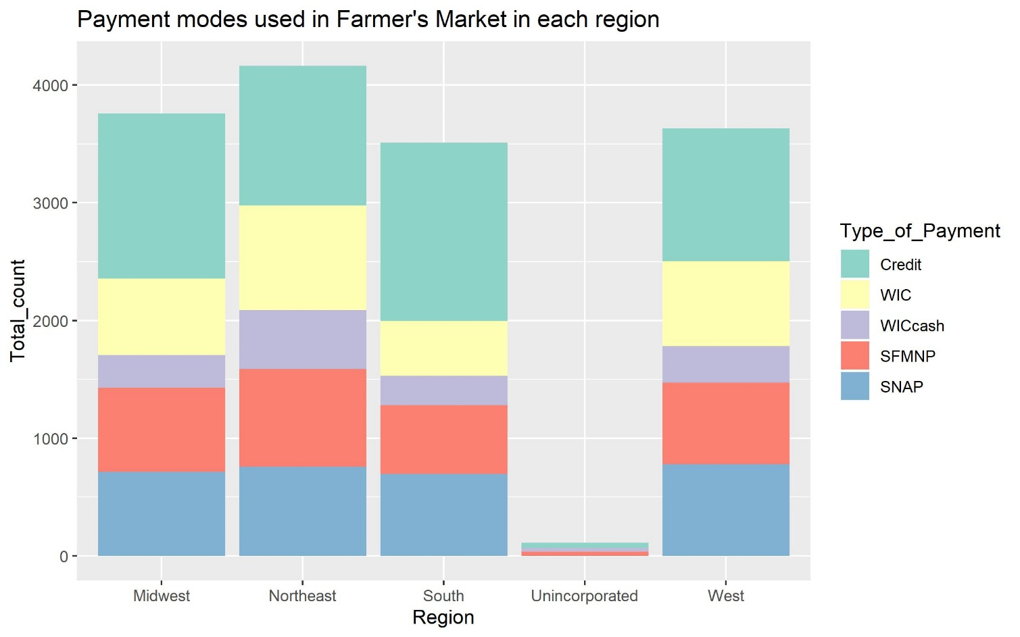

**Time Series related Analysis:**

* This line chart depicts the timeline of payment methods accepted by the farmers market from 2011 to 2019. However, this chart is based on number of fresh farmers market registrations in each year.

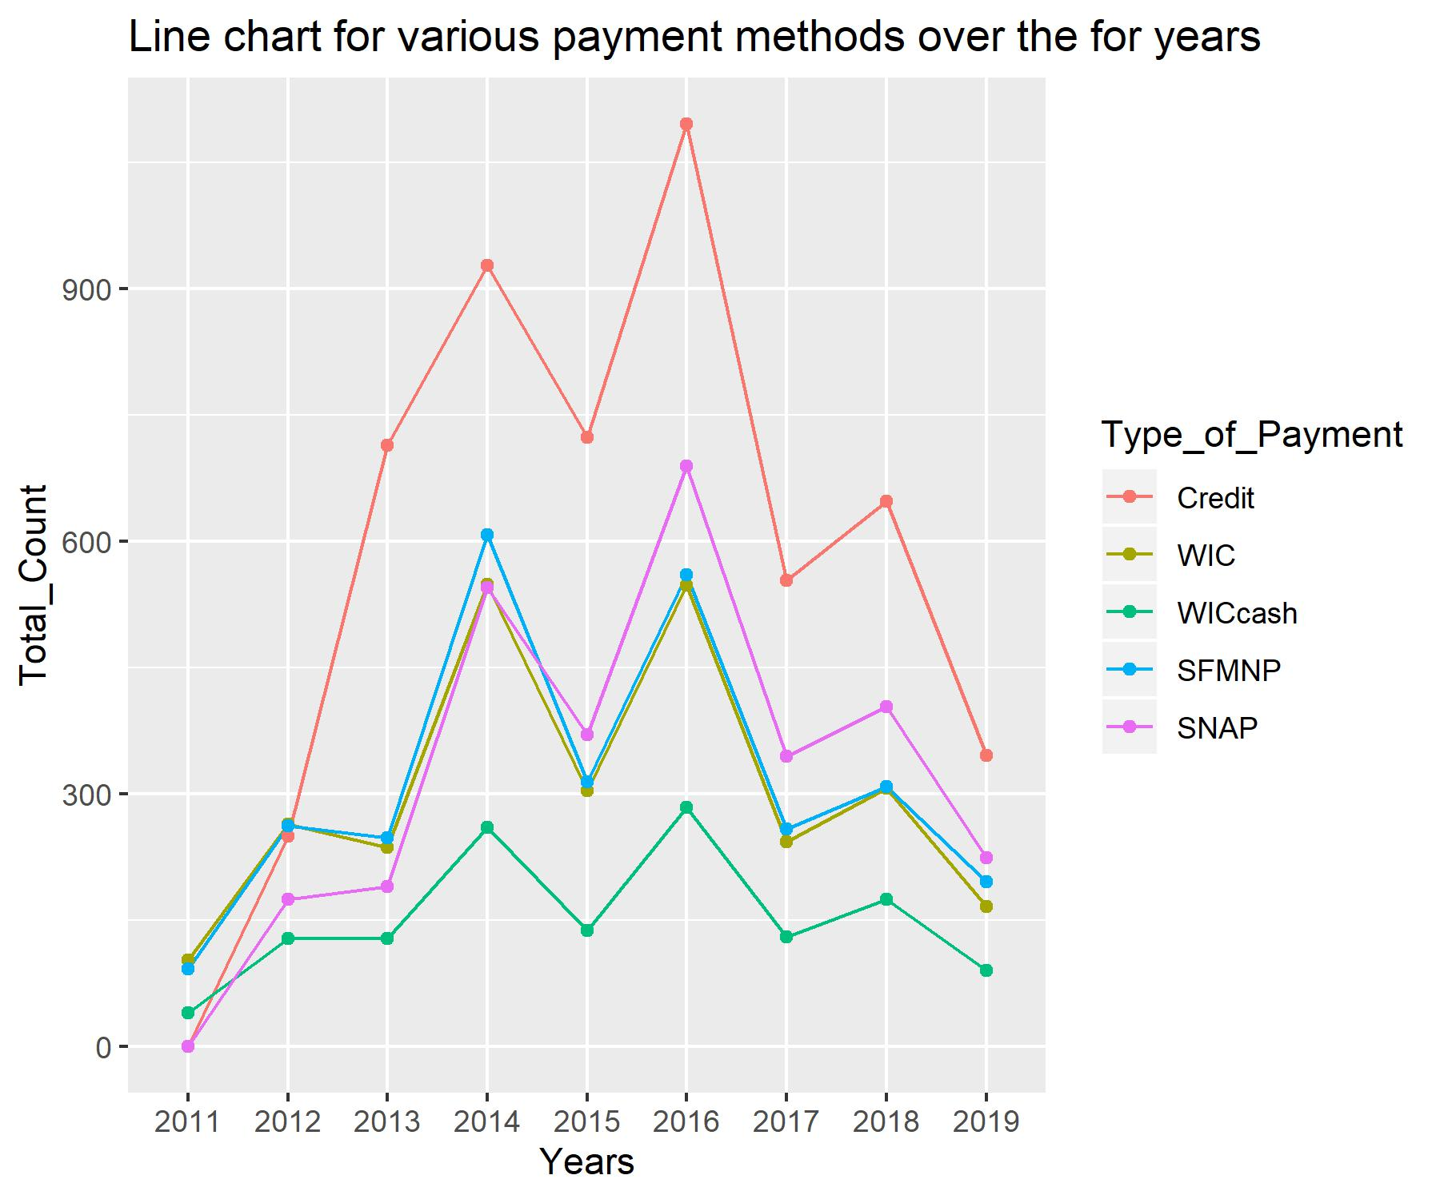

**Regional Insights:**

* This Bar plot shows top 10 states which has highest number of markets. We can observe that **California** has highest number of markets. Similarly, **New York** in Northeast, **Michigan** in North Central and **Florida** in South.

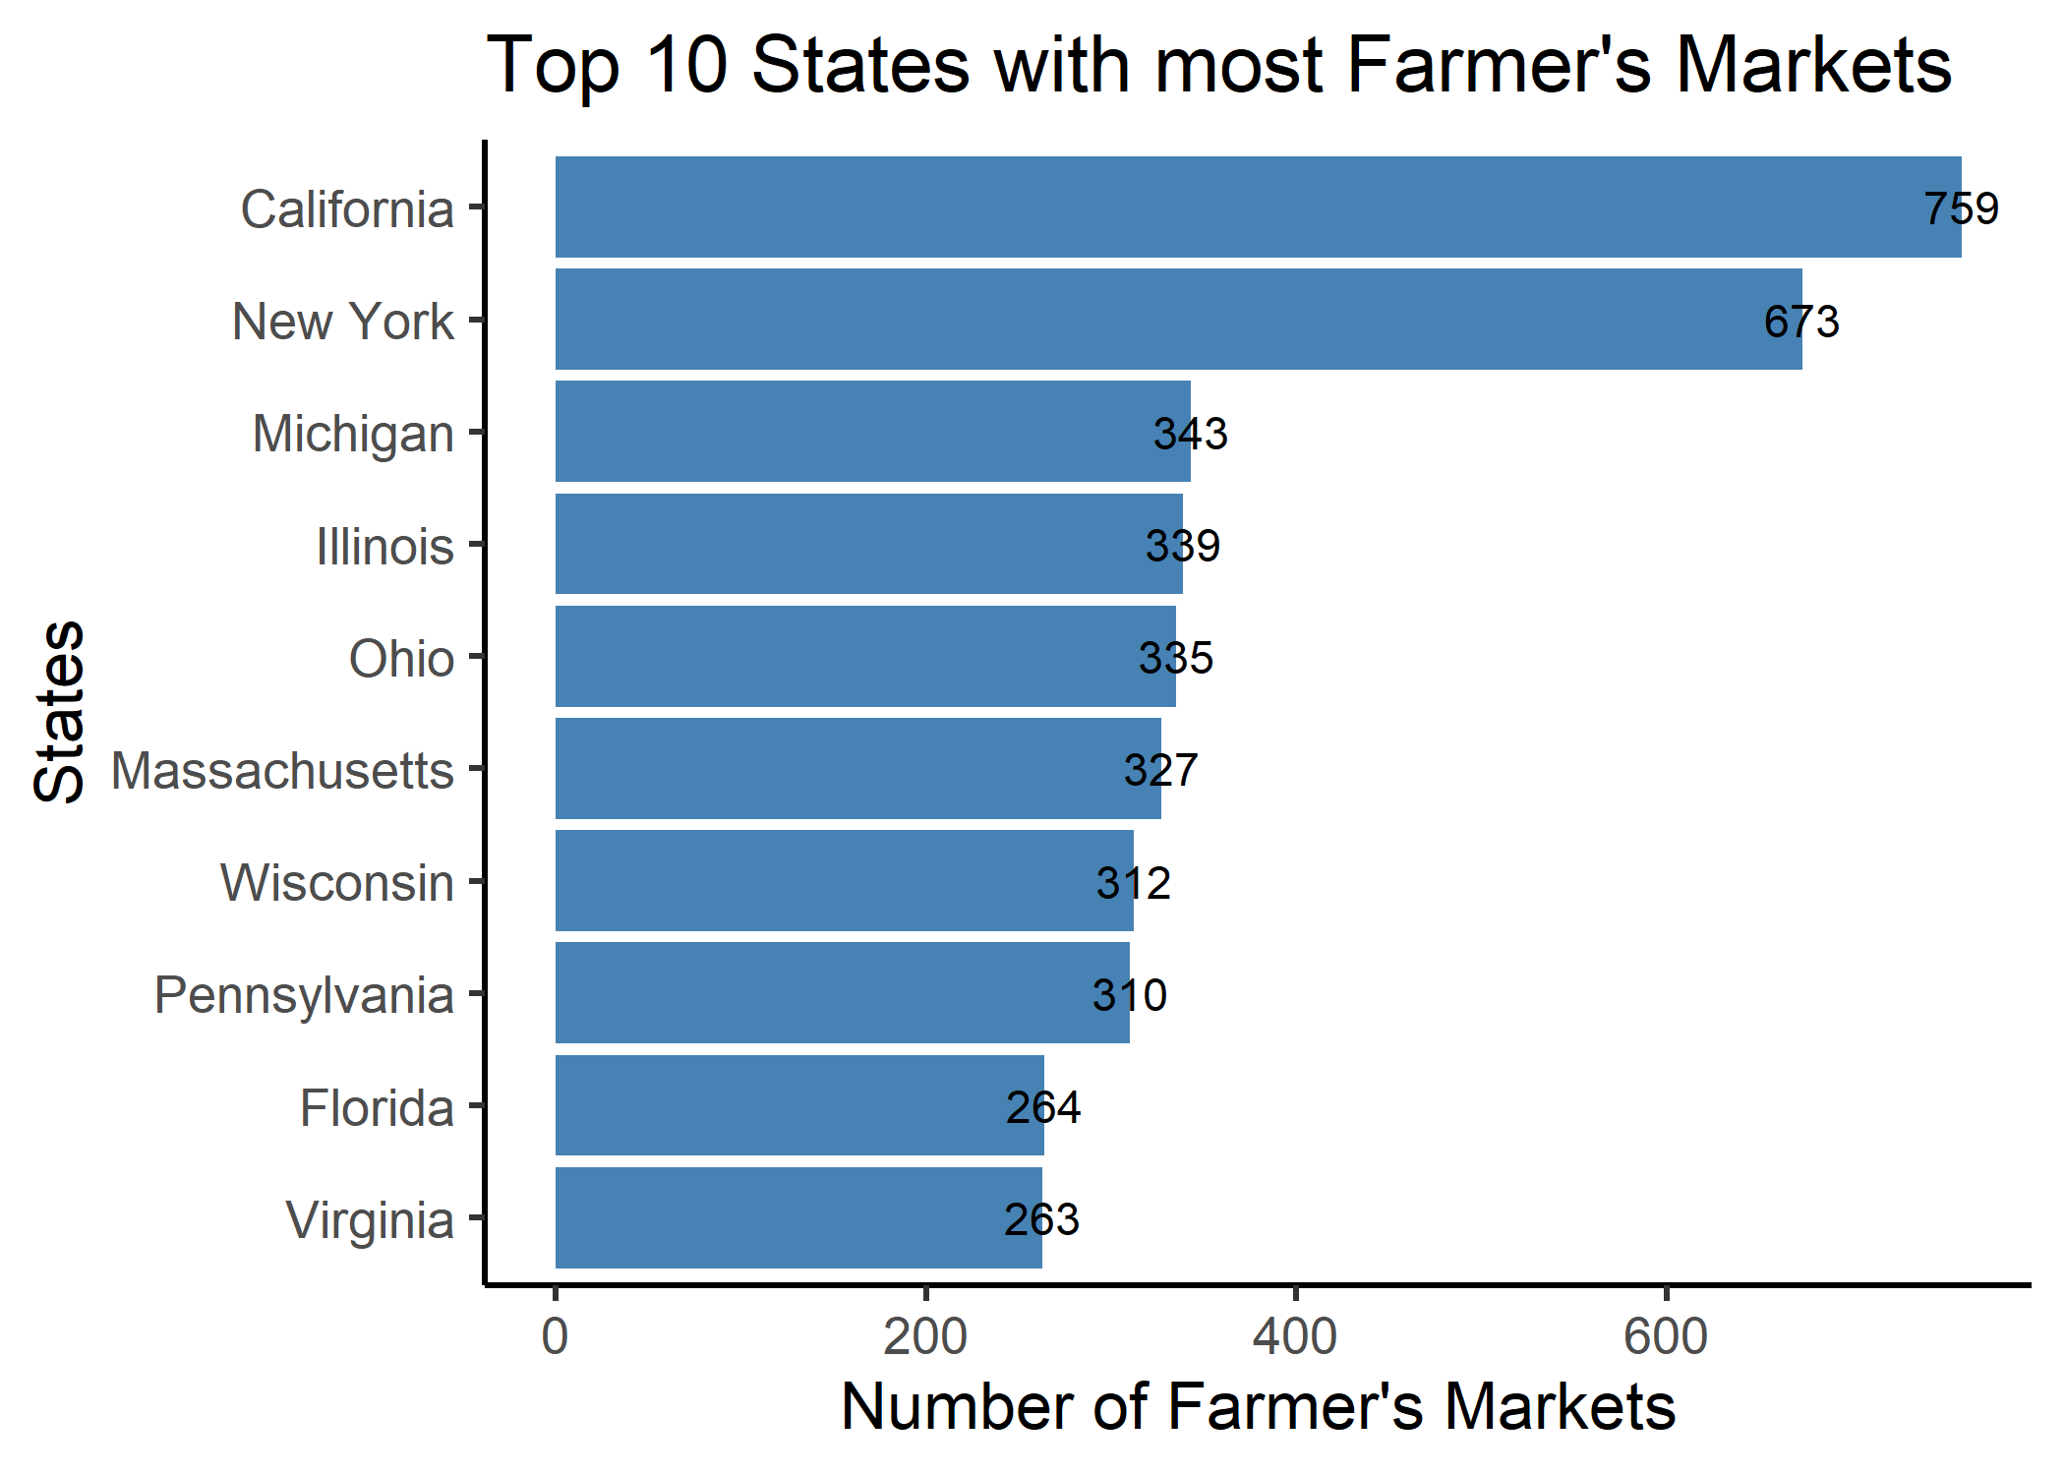

* Based on demographic values I have divided states into regions. From the Tree graph we can see that highest number of products are sold in southern region. Condiments are the highest selling products in farmers market across all the regions.

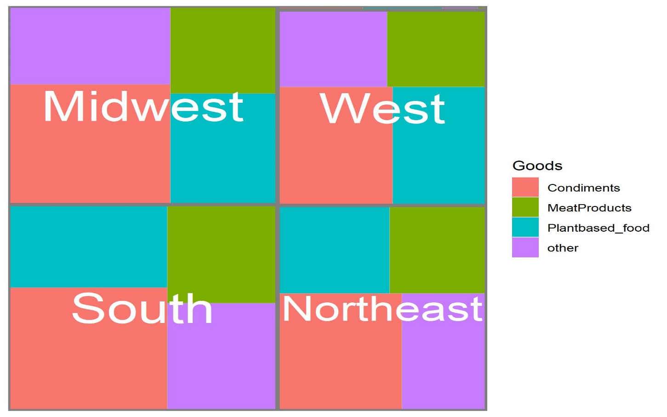

* Heat map shows the range of all product types in all regions.

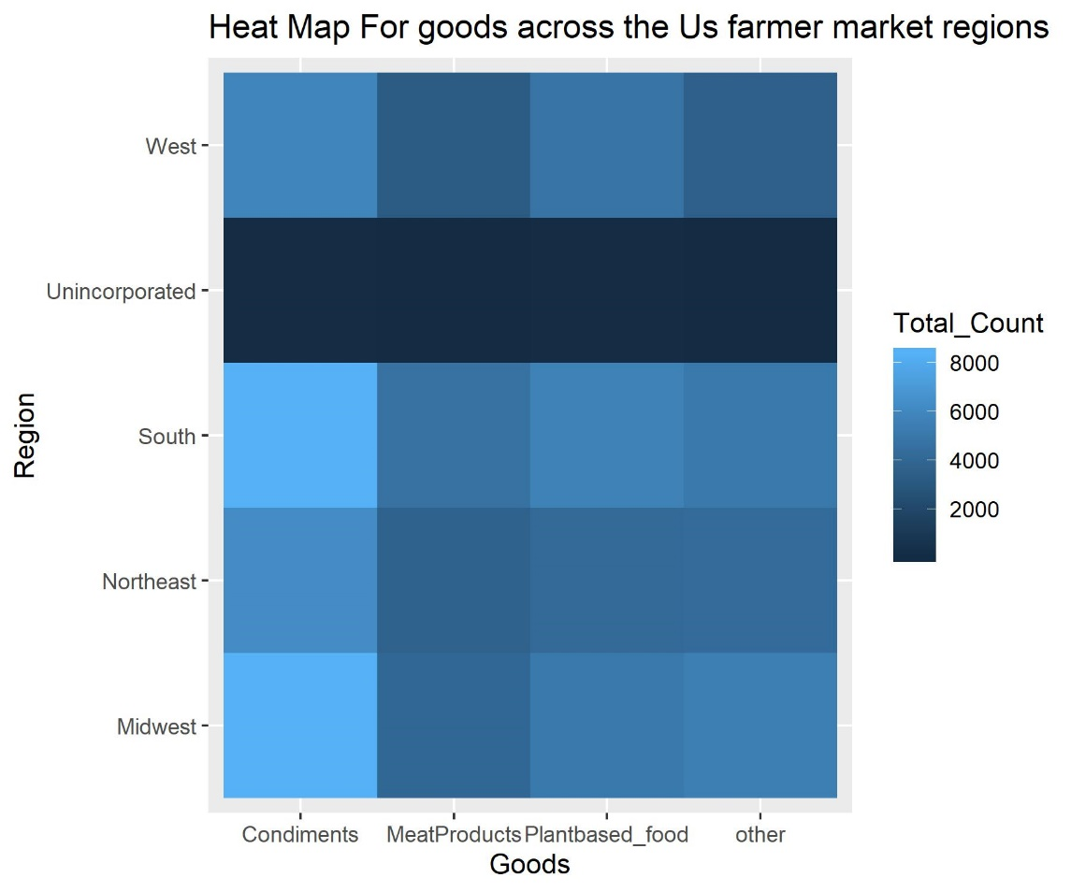

* Farmers market in Midwest region has the highest social media presence among all the other regions.

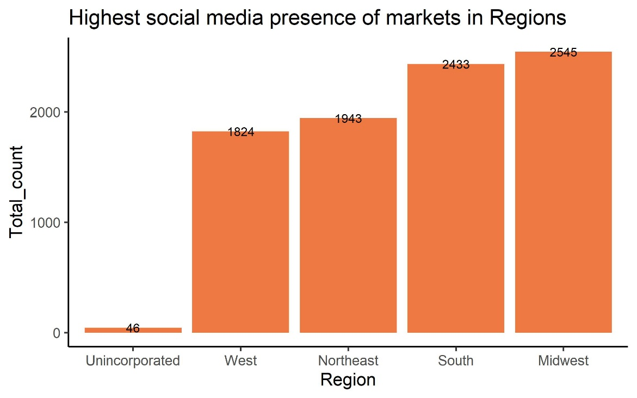

**Conclusion:** Farmers market is a great initiative to boost the agricultural income and countries economy. As products are directly sold from agricultures so they have many health benefits. In 2012 itself the value of local food purchased in farmers market is $1.4 billion.

Small and medium-sized farms account for most of the sales by farmers selling directly to consumers. Local food sales provide significant economic benefits to communities. Farmers markets also increase foot traffic and sales at neighboring businesses.

**References:**

<https://www.ams.usda.gov/sites/default/files/media/FMPP2016Highlights.pdf>

<https://www.ams.usda.gov/services/grants/fmpp/awards>

1. <https://www.ams.usda.gov/sites/default/files/media/FMPP2016Highlights.pdf>